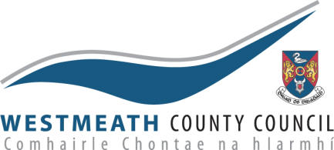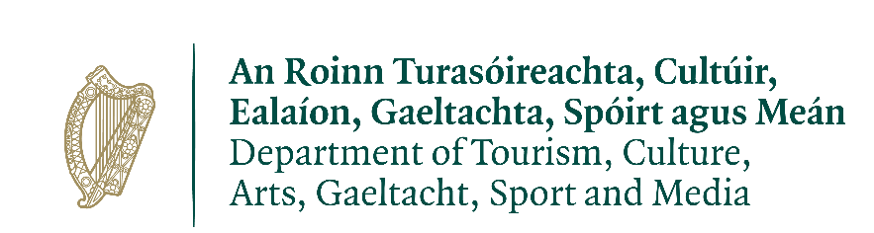

CREATIVE BURSARY AWARD SCHEME – WESTMEATH DECADE OF CENTENARIES
This scheme is intended to support Creative Practitioners (all creative art forms) to engage communities in creating new work that explores the theme of the Decade of Centenaries
INTRODUCTION
The Decade of Centenaries was initiated in 2012 with a focus on the many significant centenaries occurring during the period 2012–2016. The Centenaries Programme complements the on-going programme of annual State commemorations with special commemorative events on the centenary of key historical events. The aim of the State centenary commemoration programme for the years from 2021 – 2023 is to ensure that this complex period in our history, including the Struggle for Independence, the Civil War, the Foundation of the State and Partition, is remembered appropriately, proportionately, respectfully and with sensitivity.
Westmeath County Council Culture and Creativity Team, with funding from the Department of Tourism, Culture, Arts, Gaeltacht, Sport and Media’s Decade of Centenaries Programme, invites submissions for a special bursary which will enable creative practitioners to explore, in a creative way (be that music, performance, film, writing or another form), the themes and events of the Decade of Centenaries.
THE BURSARies
Aims:
The aim of the bursaries is to enable Creative Practitioner/s to engage meaningfully (be that through workshops or other means) with relevant individuals, communities and groups and to create work that captures the themes and stories which relate to the Decade of Centenaries, with a particular focus on themes and events relevant to Westmeath.
See Appendix 1 for a list of suggested themes to consider during 2023. Applicants may also wish to reflect on local events during the year 1923, some of which are outlined in the appendix.
- The Bursaries are intended to encourage engagement and interaction with the general public, community groups, schools and with people interested the themes and events of the Decade of Centenaries. The successful applicants will work from their own base but will have access to meeting room space in Westmeath County Council offices/libraries if required.

- In-person creative engagement (workshops, activities, show/s, performance/s or other output) is strongly encouraged. Applicants are also encouraged to consider engaging with community participants on a virtual/ online/ blended basis, where possible and appropriate.
- An online presence for the work of the bursary is encouraged. An existing platform is available.
- The successful applicant/s will be encouraged to liaise with the Westmeath Historian in Residence, where relevant, to ensure historical accuracy and complimentary programming.
- The successful applicant/s will liaise mainly with the Decade of Centenaries Coordinator (the Heritage Officer) and the project steering group (which may include, the Arts Officer and staff from Westmeath Library) may also review progress of the residency.
- Any print and/or digital outputs generated as part of this project will be considered the property of Westmeath County Council.
Amounts
It is anticipated that between three and five bursaries will be awarded ranging from €3,000 - €5,000 dependant on available budgets and proposals received. The bursary award is to include all project costs, materials, travel, etc.

Who can apply
Creative Practitioners (writers, musicians, performers, film makers etc.) at all stages to their career working in any art-form, art practice, and disciplines are invited to apply for a bursary.
Timeline:
Work funded under the bursary must be completed by 6th October 2023 award of and payments may be made in instalments as the project progresses.

APPLICATION
Requirements for applicants:
- A current tax-clearance certificate will be required. The successful applicant will be required to hold their own insurance cover.
- Demonstrate ability to deliver and coordinate by means of prior experience and/or proven track record.
- Excellent communication and interpersonal skills
Applicants’ proposals should include the following:
- A typed proposal outlining creative ideas and approaches to the bursary (no more than two pages). The proposal should include specific ideas on work and methods of engagement on the theme and/or events of the Decade of Centenaries (refer to Appendix 1), an outline of suggestions for public/schools/community engagement to include an indicative breakdown of proposed time for public engagement.
- A typed curriculum vitae (maximum 3 pages) with two named referees, which should include someone who has previously worked with you on community engagement opportunities.
- Proposals should include images where relevant.
- Only one application per individual artist will be accepted under this scheme.
- The decision of the independent assessment panel will be final and no correspondence will be entered into concerning an award.
Please send application and a current CV marked ‘Creative Bursary’ by email to: heritage@westmeathcoco.ie
Note: capital costs, e.g. for equipment, are ineligible

The deadline for completed applications is Mon 12th June at 12 noon.
Any queries should be addressed to Melanie McQuade, Decade of Centenaries co-ordinator via heritage@westmeathcoco.ie
Applications will be assessed under the following criteria:
Criterion | Mark
Project proposal – quality of proposal, Artistic merit of the proposal | - Marks
Experience/proven track record; Quality of previous work | 30 Marks
Demonstrate good communication skills including proficiency in the use of digital platforms, track record in public engagement activities including any related online activities | 20 Marks
Demonstrate familiarity with and interest in the subject matter. Relevance and suitability of the proposal | 20 Marks
 | Total: 100 Marks

Westmeath County Council reserves the right to shortlist candidates and interviews may be held with selected candidates prior to the final evaluation. Westmeath County Council reserve the right not to appoint if the applications received are deemed to be unsuitable. In such an instance the right is reserved to pursue a different procurement / selection process.
In advance of the commencement of the bursary the following will be agreed with the successful applicant
- Goals, roles and responsibilities between the creative practitioner and the Decade of Centenaries co-ordinator and/or the Culture Team of Westmeath County Council
- Agreed programme of work with appropriate flexibility and responsiveness
- Ongoing review and evaluation; regularity of meetings
This residency is funded under the Department of Tourism, Culture, Arts, Gaeltacht, Sport and Media’s Decade of Centenaries Programme. The objectives of this programme are set out on the Department website.

